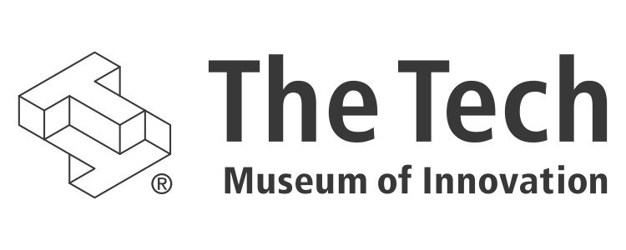

The Tech Studio

Beta opening in 2013; redesign and expansion in 2015

# the tech. reinvented.

In 2012, The Tech Museum of Innovation launched The Tech 3.0 campaign, a five-year institutional transformation that is redefining the museum as a Silicon Valley resource for innovation. The Tech aims to do this by creating deep experiences that are open-ended, social, and collaborative. New galleries include Social Robots, which challenges visitors to design and program a robot for human interaction in real-world settings, and Body Metrics, which uses technology to create a digital reflection of visitors that enables them to assess their lifestyles’ influence on health in new ways. Additional “design challenge” galleries will cover the museum’s 30,000-square-foot lower level. The gallery makeovers on the upper level also will reflect this deeper engagement and highlight the impact of innovation on the world. The Tech Studio is the core of the lower level with multiple hands-on activities taking place daily.

# what is the tech studio?

The Tech Studio is a collaborative programming, design, digital fabrication, and prototype testing space within the museum. Educators use this space for “maker” projects; community groups use it for meet-ups and hackathons; and our exhibits team uses it to create and test new exhibit ideas.

**Put simply, The Tech Studio hosts the coolest hands-on workshops and activities at the museum.** It will be the focal point of our new Creative Collisions initiative.

# the tech studio programs

The Tech Studio runs a growing slate of ongoing programs. The Tech’s staff run maker workshops and student maker programs, including Open Make @ The Tech. Creative organizations and informal groups often conduct workshops here in conjunction with museum staff, such as Hack the Future. University and corporate researchers reserve the space and draw from our visitor audience for prototype testing. Corporate partners use the space for recruiting events, team-building, design-thinking workshops, hackathons, and the like. Below are a few of the events that have taken place recently in The Tech Studio.

* 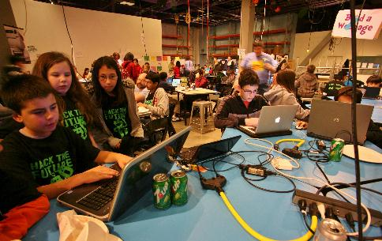Arduino workshops <http://www.thetech.org/partnership-programs-tech/arduino-workshops-tech>
* Google Linux Developers Meeting
* Moore Foundation Ocean Project Conference
* VTA “Hack My Ride” Hackathon
* Bay Area Makers Startup Weekend (July 2014) <http://startupweekend.org>

*Hack the Future Workshop*

* 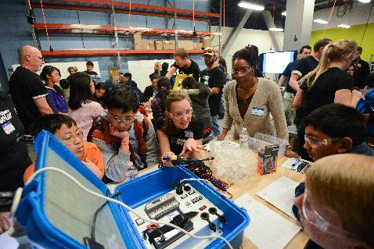STEAM Dojo workshops by Benesse <http://www.thetech.org/partnership-programs-tech/steam-dojo-benesse-lightcube>
* Hack the Future <http://hackthefuture.org/next/>
* Technovation [www.technovationchallenge.org](http://www.technovationchallenge.org)
* Open Make <http://www.thetech.org/partnership-programs-tech/open-make-tech>
* Young Makers <http://youngmakers.org>

*Social Innovation workshop with We Share Solar*

* SparkFun National Tour Educator Workshop <https://learn.sparkfun.com/>
* Santa Clara University Educator Workshop
* Future of Live Musical Performance by Stanford d.school
* Beta Jams <http://www.thetech.org/partnership-programs-tech/beta-jam>
  + Motion math
  + Sifteo
  + GigaBryte
  + Learning, Design, and Technology Program, Stanford  
      
    University

*Open Make at The Tech*

* + Play-i
  + Roominate
  + Tangible Play
  + AgIC
  + Tangiblock by Benesse

# creative collisions

*CoderDojo at The Tech*

The Tech soon will launch a regular program in The Tech Studio called Creative Collisions. Each event will attract 250 participants who will gather in The Studio and The Tech’s lower level for the community’s most creative and meaningful meet-ups. Creative Collisions nights will attract people active in all aspects of Silicon Valley’s life: hardware, software, finance, research, engineering, development, and everything in between. The program will be designed to encourage participants to interact over the subject matter, great food, and a lively environment. Creative Collisions officially debuts in Spring 2015. It will be held monthly at first and gradually become a weekly event.

# facilities and equipment

Located on the museum’s lower level, The Tech Studio will occupy about 4,000 square feet across a fabrication lab, workshop, and programming space.

Through the use of flexible partitions and wheeled components, the arrangement of the space is very fluid. The shop’s digital fabrication equipment includes 3D printers, a CNC router/mill, laser cutter (coming soon), vinyl cutter, eco-solvent printer, vacuum former, and hot wire cutter. The workshop includes movable worktables, power drops, extensive shelving for supplies, white boards, and large-format LCD screens as well as electronics tools, hand tools, and a wide array of maker supplies. The fabrication lab and workshop open out to the museum galleries so that all technologies and activities are visible to museum visitors. The design processes practiced daily in The Tech Studio by The Tech staff and visiting experts serve as a model for partner organizations to learn from as they leverage the flexible space that’s supported by a large projection screen, new sound system, and movable seating and tables. The Tech Studio currently is undergoing a major expansion and redesign in anticipation of our Creative Collisions program.

# 3d printing programs

The Tech has a number of 3D printers, also known as additive manufacturing devices, in The Tech Studio’s digital fabrication lab. The Tech’s exhibits team uses these machines for exhibit development, printing prototype parts for new exhibits in the public view. The Tech staff runs a series of maker workshops and student maker programs that use these machines as well. Using software from sponsors such as Autodesk and TinkerCad, visitors can design solutions to problems and then print out prototypes. The 3D printers are set up in the fabrication lab with monitors mounted overhead that allow visitors to see the 3D models being printed.

# timeline

Opened in Beta 2013, redesign and expansion 2015.

# budget

$3 million

# your opportunity

A gift to The Tech Studio will align your company with a one-of-a-kind learning experience for the 21st century workforce. Donors will be recognized on the entrance to The Tech Studio (“The Tech Studio, sponsored by YOUR NAME HERE.”), and will be entitled to many other benefits, including friends and family memberships and admission tickets, and discounts on museum rentals.

# in gratitude

We value your consideration of partnership to support this work at The Tech and in the Silicon Valley community and look forward to many years of mutually beneficial collaboration. If you have any questions, we would be happy to discuss them and share more details of this exciting project. Thank you for your consideration of this philanthropic opportunity.

**For information, contact:   
Maria Pappas  
Vice President, Development  
(408) 795-6301  
mpappas@thetech.org**